SOCIAL MEDIA AND MARKETING EXECUTIVE APPLICATION
DEADLINE: FRIDAY 1ST APRIL 2022
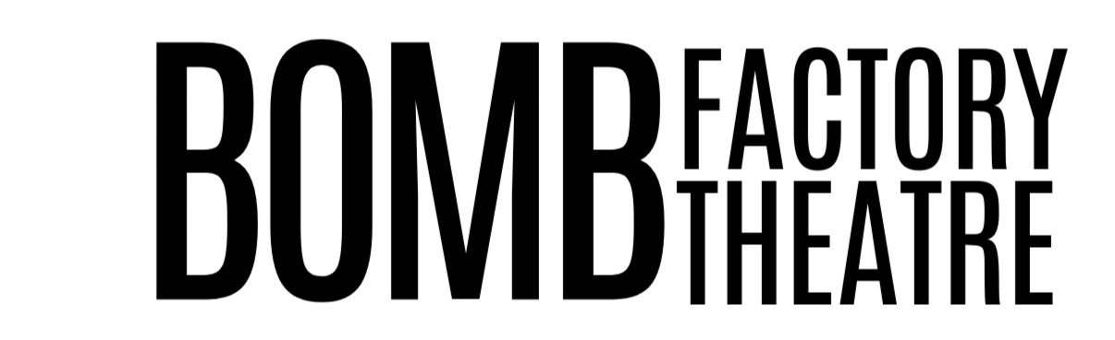
We are looking for a Social Media and Marketing executive to join our team.
Our ethos is simple. We want to rectify the issue of under representation within the industry. We are a women led new writing company platforming work solely by female and non-binary identifying writers. As a company, we are aiming to establish a reputation for sensitivity and inclusivity in terms of content and casting. We want writers to feel confident in approaching us as a company who strives to represent every sector of society. We are keen to continue to generate a hub of cultural celebration through our theatrical work and are looking for a Social Media and Marketing Executive to help further cement our ambitions as a company.

We are a registered CIC (Community Interest Company). As well as platforming theatre, we also provide workshops in our permanent venue at the Bomb Factory Art Foundation in Archway, London and work with young people and the local community in the Borough of Islington.

Please note that every member of our company is paid ONLY when projects arise. With Arts Council and local council funding, we are able to pay all artists and creatives Equity minimum or above but only once funding has been approved and projects are underway. We are a close knit company who all work together, share responsibilities and have equal creative input into the nature of our produced work.

Your role as Social Media and Marketing executive will entail:
- Creating and managing posts on our social media platforms including Twitter, Instagram and Facebook
- Keeping our website updated
- Creating posters for projects and shows

Please complete the following form and send it alongside a CV and any examples of relevant previous work to merle@bombfactorytheatre.com

PLEASE WRITE “PREFER NOT TO SAY” IF YOU WOULD RATHER NOT ANSWER ANY OF OUR FOLLOWING QUESTIONS.

FULL NAME:
D.O.B:
PRONOUNS:
ETHNICITY:
DO YOU CONSIDER YOURSELF TO HAVE A DISABILITY?
AREA OF RESIDENCE:

Thank you. We will be in touch!

